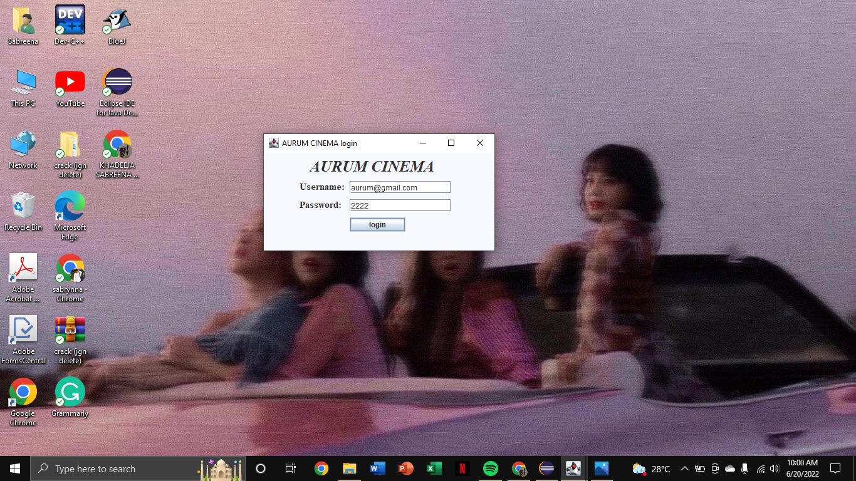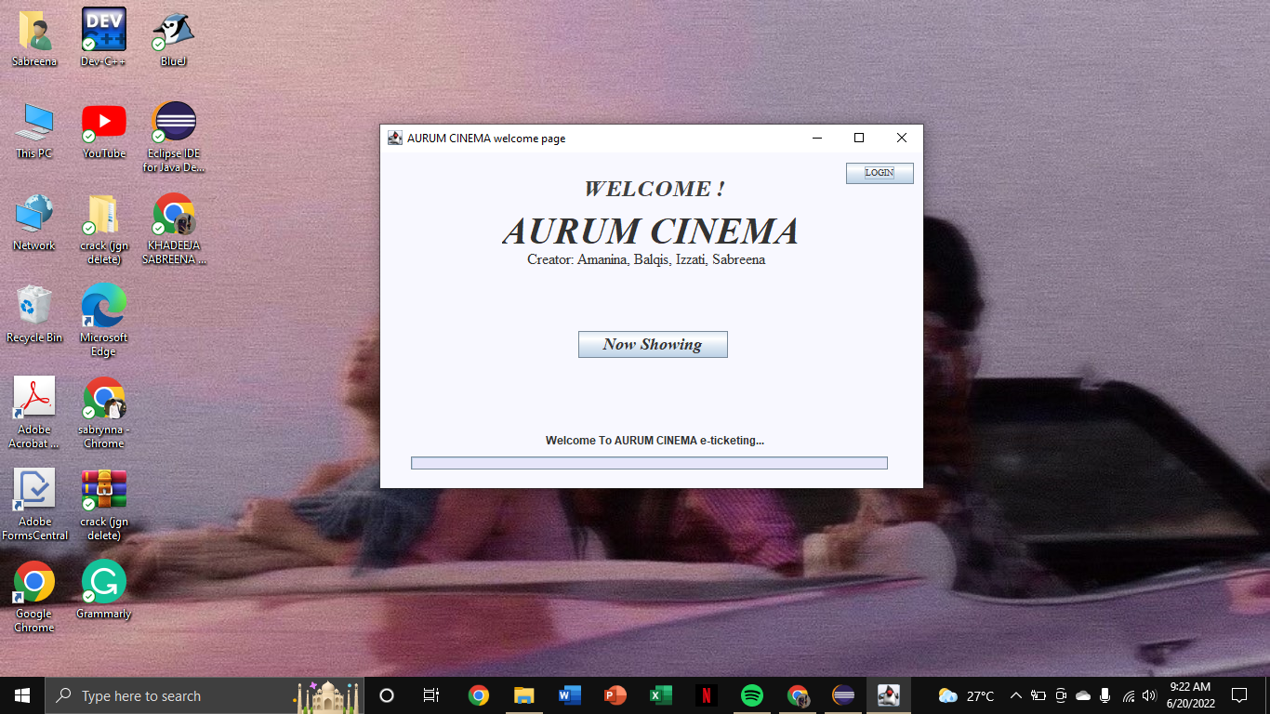**User Manual Aurum Cinema (Easy to follow)**

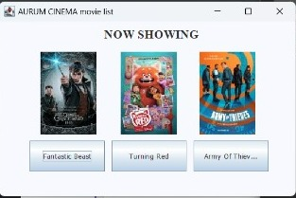

1. Welcome page
2. In the front page, you will see the Now Showing and Login button.
3. Click login, if you want to login to the website
4. Next, fill in your email and also your password then press the login button.
5. And then it will show up in the Movie List. If you didn’t log in first, you can just click the Now Showing button on the welcome page to see the movie list.

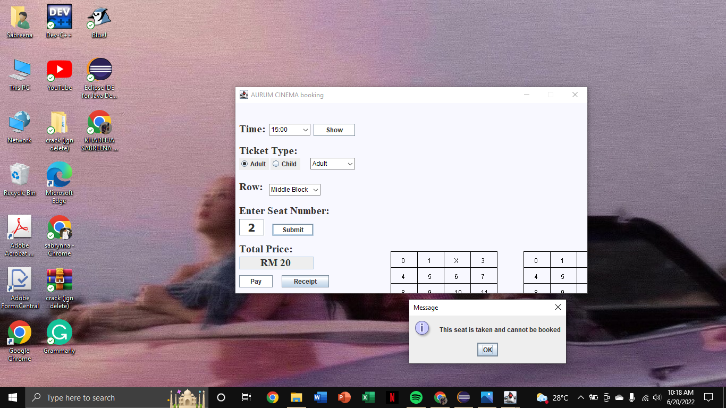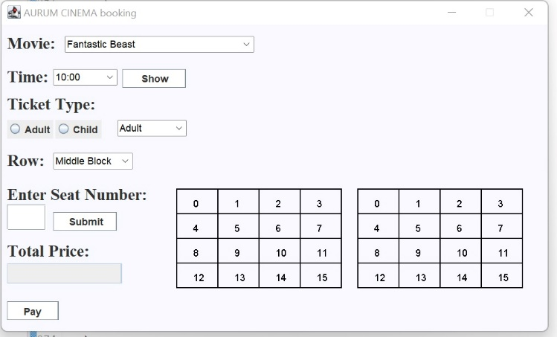

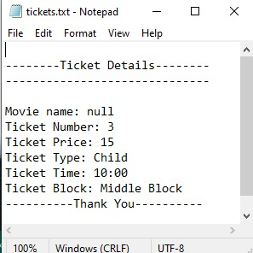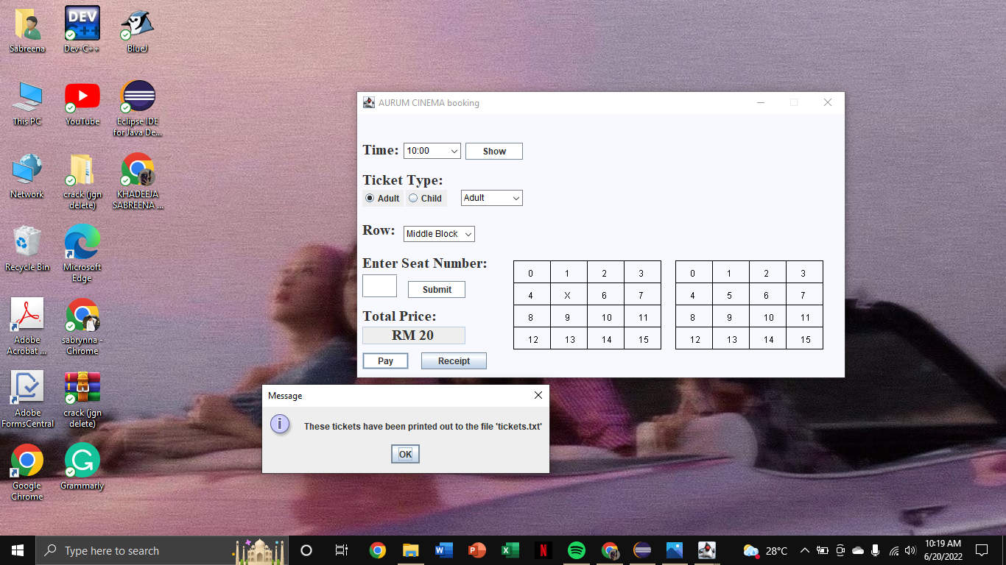

2. Booking a ticket.

a. After you pick a movie, it comes out the booking page next.

b. Select the time, ticket type, seat row, and also seat number then submit.

c. The price will show up but if the seat is taken then it’ll pop up “this seat is taken and d. cannot be booked”

e. But if the seat is not taken then it will calculate the total price.

f. Click the pay button and the message will appear that says “these tickets have been printed out to the file ‘tickets.txt’” and it will show the receipt of the ticket..